# Experiment Design for Creating Visualizations using D3.js on a Finance Dataset

## Objectives

* + To explore and visualize a dataset related to **Finance/Banking/Insurance/Credit** using

## D3.js.

* + To create **basic visualizations** (Bar chart, Pie chart, Histogram, Timeline chart, Scatter plot, Bubble plot) to understand data distribution and trends.
  + To create **advanced visualizations** (Word chart, Box and Whisker plot, Violin plot, Regression plot, 3D chart, Jitter) for deeper insights and complex relationships.
  + To perform **hypothesis testing** using the **Pearson correlation coefficient** to evaluate relationships between numerical variables in the dataset.

1. Charts Code

<!DOCTYPE html>

<html>

<head>

    <title>Investment Analysis Dashboard</title>

    <script src="https://cdnjs.cloudflare.com/ajax/libs/d3/7.8.5/d3.min.js"></script>

    <style>

        body {

            font-family: Arial, sans-serif;

            margin: 0;

            padding: 20px;

            background-color: #f5f5f5;

        }

        .dashboard {

            display: grid;

            grid-template-columns: repeat(2, 1fr);

            gap: 20px;

            padding: 20px;

            max-width: 1200px;

            margin: 0 auto;

        }

        .chart-container {

            background: #fff;

            border-radius: 8px;

            padding: 15px;

            box-shadow: 0 2px 4px rgba(0,0,0,0.1);

        }

        .title {

            font-size: 18px;

            font-weight: bold;

            margin-bottom: 15px;

            text-align: center;

            color: #333;

        }

        .tooltip {

            position: absolute;

            padding: 8px;

            background: rgba(0,0,0,0.8);

            color: #fff;

            border-radius: 4px;

            font-size: 12px;

            pointer-events: none;

        }

        .file-input-container {

            text-align: center;

            margin: 20px 0;

        }

        .file-input-container input {

            padding: 10px;

            border: 2px solid #ddd;

            border-radius: 4px;

        }

        .loading {

            text-align: center;

            color: #666;

            margin: 20px 0;

            display: none;

        }

        svg {

            max-width: 100%;

            height: auto;

        }

    </style>

</head>

<body>

 =<h1 style="text-align: center; margin: 20px 0; color: #333;">Investment Analysis Dashboard</h1>

 <div class="file-input-container">

     <input type="file" id="csvFile" accept=".csv" />

 </div>

 <div id="loading" class="loading">Loading data...</div>

 <div class="dashboard">

     <div class="chart-container">

         <div class="title">Gender Distribution</div>

         <div id="gender-chart"></div>

     </div>

     <div class="chart-container">

         <div class="title">Age Distribution</div>

         <div id="age-chart"></div>

     </div>

     <div class="chart-container">

         <div class="title">Investment Preferences</div>

         <div id="investment-preferences"></div>

     </div>

     <div class="chart-container">

         <div class="title">Expected Returns Distribution</div>

         <div id="expected-returns"></div>

     </div>

     <div class="chart-container">

         <div class="title">Investment Duration</div>

         <div id="investment-duration"></div>

     </div>

     <div class="chart-container">

         <div class="title">Investment Objectives</div>

         <div id="investment-objectives"></div>

     </div>

     <div class="chart-container">

         <div class="title">Investment Distribution (Box Plot)</div>

         <div id="box-plot"></div>

     </div>

     <div class="chart-container">

         <div class="title">Age vs Investment Preference (Violin Plot)</div>

         <div id="violin-plot"></div>

     </div>

     <div class="chart-container">

         <div class="title">Age vs Investment Preference (Regression)</div>

         <div id="regression-plot"></div>

     </div>

     <div class="chart-container">

         <div class="title">3D Investment Preference Analysis</div>

         <div id="scatter-3d"></div>

     </div>

 </div>

<script>

// Set up the file input handler

document.getElementById('csvFile').addEventListener('change', handleFileSelect);

function handleFileSelect(event) {

    const file = event.target.files[0];

    const loading = document.getElementById('loading');

    if (file) {

        loading.style.display = 'block';

        const reader = new FileReader();

        reader.onload = function(e) {

            const text = e.target.result;

            const data = d3.csvParse(text, d3.autoType);

            clearCharts();

            createAllCharts(data);

            loading.style.display = 'none';

        };

        reader.readAsText(file);

    }

}

function clearCharts() {

    d3.selectAll("svg").remove();

}

function createGenderChart(data) {

    const width = 300;

    const height = 300;

    const radius = Math.min(width, height) / 2;

    const svg = d3.select("#gender-chart")

        .append("svg")

        .attr("width", width)

        .attr("height", height)

        .append("g")

        .attr("transform", `translate(${width/2},${height/2})`);

    const genderCount = d3.group(data, d => d.gender);

    const pieData = Array.from(genderCount, ([key, value]) => ({

        gender: key,

        count: value.length

    }));

    const color = d3.scaleOrdinal()

        .domain(pieData.map(d => d.gender))

        .range(["#FF6B6B", "#4ECDC4"]);

    const pie = d3.pie()

        .value(d => d.count);

    const arc = d3.arc()

        .innerRadius(0)

        .outerRadius(radius - 40);

    const arcs = svg.selectAll("arc")

        .data(pie(pieData))

        .enter()

        .append("g");

    // Add tooltip

    const tooltip = d3.select("body").append("div")

        .attr("class", "tooltip")

        .style("opacity", 0);

    arcs.append("path")

        .attr("d", arc)

        .attr("fill", d => color(d.data.gender))

        .attr("stroke", "white")

        .style("stroke-width", "2px")

        .on("mouseover", function(event, d) {

            tooltip.transition()

                .duration(200)

                .style("opacity", .9);

            tooltip.html(`${d.data.gender}: ${d.data.count}`)

                .style("left", (event.pageX) + "px")

                .style("top", (event.pageY - 28) + "px");

        })

        .on("mouseout", function(d) {

            tooltip.transition()

                .duration(500)

                .style("opacity", 0);

        });

    // Add labels

    arcs.append("text")

        .attr("transform", d => `translate(${arc.centroid(d)})`)

        .attr("text-anchor", "middle")

        .text(d => `${d.data.gender}`);

}

function createAgeChart(data) {

    const margin = {top: 20, right: 20, bottom: 30, left: 40};

    const width = 400 - margin.left - margin.right;

    const height = 300 - margin.top - margin.bottom;

    const svg = d3.select("#age-chart")

        .append("svg")

        .attr("width", width + margin.left + margin.right)

        .attr("height", height + margin.top + margin.bottom)

        .append("g")

        .attr("transform", `translate(${margin.left},${margin.top})`);

    const x = d3.scaleLinear()

        .domain([d3.min(data, d => d.age) - 2, d3.max(data, d => d.age) + 2])

        .range([0, width]);

    const histogram = d3.histogram()

        .value(d => d.age)

        .domain(x.domain())

        .thresholds(x.ticks(10));

    const bins = histogram(data);

    const y = d3.scaleLinear()

        .domain([0, d3.max(bins, d => d.length)])

        .range([height, 0]);

    svg.append("g")

        .attr("transform", `translate(0,${height})`)

        .call(d3.axisBottom(x));

    svg.append("g")

        .call(d3.axisLeft(y));

    svg.selectAll("rect")

        .data(bins)

        .enter()

        .append("rect")

        .attr("x", d => x(d.x0) + 1)

        .attr("width", d => Math.max(0, x(d.x1) - x(d.x0) - 1))

        .attr("y", d => y(d.length))

        .attr("height", d => height - y(d.length))

        .style("fill", "#69b3a2")

        .style("opacity", 0.8);

}

function createInvestmentPreferencesChart(data) {

    const margin = {top: 20, right: 20, bottom: 70, left: 40};

    const width = 400 - margin.left - margin.right;

    const height = 300 - margin.top - margin.bottom;

    const svg = d3.select("#investment-preferences")

        .append("svg")

        .attr("width", width + margin.left + margin.right)

        .attr("height", height + margin.top + margin.bottom)

        .append("g")

        .attr("transform", `translate(${margin.left},${margin.top})`);

    const investmentTypes = ['Mutual_Funds', 'Equity_Market', 'Debentures',

                           'Government_Bonds', 'Fixed_Deposits', 'PPF', 'Gold'];

    const averages = investmentTypes.map(type => ({

        type: type.replace('_', ' '),

        value: d3.mean(data, d => d[type])

    }));

    const x = d3.scaleBand()

        .range([0, width])

        .domain(averages.map(d => d.type))

        .padding(0.2);

    const y = d3.scaleLinear()

        .domain([0, d3.max(averages, d => d.value)])

        .range([height, 0]);

    svg.append("g")

        .attr("transform", `translate(0,${height})`)

        .call(d3.axisBottom(x))

        .selectAll("text")

        .attr("transform", "rotate(-45)")

        .style("text-anchor", "end");

    svg.append("g")

        .call(d3.axisLeft(y));

    svg.selectAll("bars")

        .data(averages)

        .enter()

        .append("rect")

        .attr("x", d => x(d.type))

        .attr("y", d => y(d.value))

        .attr("width", x.bandwidth())

        .attr("height", d => height - y(d.value))

        .attr("fill", "#4CAF50");

}

function createExpectedReturnsChart(data) {

    const width = 300;

    const height = 300;

    const radius = Math.min(width, height) / 2;

    const svg = d3.select("#expected-returns")

        .append("svg")

        .attr("width", width)

        .attr("height", height)

        .append("g")

        .attr("transform", `translate(${width/2},${height/2})`);

    const returnsCount = d3.group(data, d => d.Expect);

    const pieData = Array.from(returnsCount, ([key, value]) => ({

        returns: key,

        count: value.length

    }));

    const color = d3.scaleOrdinal()

        .domain(pieData.map(d => d.returns))

        .range(d3.schemeSet3);

    const pie = d3.pie()

        .value(d => d.count);

    const arc = d3.arc()

        .innerRadius(radius * 0.4)

        .outerRadius(radius - 40);

    const arcs = svg.selectAll("arc")

        .data(pie(pieData))

        .enter()

        .append("g");

    arcs.append("path")

        .attr("d", arc)

        .attr("fill", d => color(d.data.returns))

        .attr("stroke", "white")

        .style("stroke-width", "2px");

    arcs.append("text")

        .attr("transform", d => `translate(${arc.centroid(d)})`)

        .attr("text-anchor", "middle")

        .style("font-size", "12px")

        .text(d => d.data.returns);

}

function createInvestmentDurationChart(data) {

    const margin = {top: 20, right: 20, bottom: 70, left: 40};

    const width = 400 - margin.left - margin.right;

    const height = 300 - margin.top - margin.bottom;

    const svg = d3.select("#investment-duration")

        .append("svg")

        .attr("width", width + margin.left + margin.right)

        .attr("height", height + margin.top + margin.bottom)

        .append("g")

        .attr("transform", `translate(${margin.left},${margin.top})`);

    const durationCount = Array.from(d3.group(data, d => d.Duration),

        ([key, value]) => ({duration: key, count: value.length}));

    const x = d3.scaleBand()

        .range([0, width])

        .domain(durationCount.map(d => d.duration))

        .padding(0.2);

    const y = d3.scaleLinear()

        .domain([0, d3.max(durationCount, d => d.count)])

        .range([height, 0]);

    svg.append("g")

        .attr("transform", `translate(0,${height})`)

        .call(d3.axisBottom(x))

        .selectAll("text")

        .attr("transform", "rotate(-45)")

        .style("text-anchor", "end");

    svg.append("g")

        .call(d3.axisLeft(y));

    svg.selectAll("bars")

        .data(durationCount)

        .enter()

        .append("rect")

        .attr("x", d => x(d.duration))

        .attr("y", d => y(d.count))

        .attr("width", x.bandwidth())

        .attr("height", d => height - y(d.count))

        .attr("fill", "#FF9800");

}

function createInvestmentObjectivesChart(data) {

    const margin = {top: 20, right: 20, bottom: 70, left: 40};

    const width = 400 - margin.left - margin.right;

    const height = 300 - margin.top - margin.bottom;

    const svg = d3.select("#investment-objectives")

        .append("svg")

        .attr("width", width + margin.left + margin.right)

        .attr("height", height + margin.top + margin.bottom)

        .append("g")

        .attr("transform", `translate(${margin.left},${margin.top})`);

    const objectiveCount = Array.from(d3.group(data, d => d.Objective),

        ([key, value]) => ({objective: key, count: value.length}));

    const x = d3.scaleBand()

        .range([0, width])

        .domain(objectiveCount.map(d => d.objective))

        .padding(0.2);

    const y = d3.scaleLinear()

        .domain([0, d3.max(objectiveCount, d => d.count)])

        .range([height, 0]);

    svg.append("g")

        .attr("transform", `translate(0,${height})`)

        .call(d3.axisBottom(x))

        .selectAll("text")

        .attr("transform", "rotate(-45)")

        .style("text-anchor", "end");

    svg.append("g")

        .call(d3.axisLeft(y));

    svg.selectAll("bars")

        .data(objectiveCount)

        .enter()

        .append("rect")

        .attr("x", d => x(d.objective))

        .attr("y", d => y(d.count))

        .attr("width", x.bandwidth())

        .attr("height", d => height - y(d.count))

        .attr("fill", "#9C27B0");

}

// Function to create all charts with the loaded data

function createAllCharts(data) {

    createGenderChart(data);

    createAgeChart(data);

    createInvestmentPreferencesChart(data);

    createExpectedReturnsChart(data);

    createInvestmentDurationChart(data);

    createInvestmentObjectivesChart(data);

    // createWordCloud(data);

    createBoxPlot(data);

    createViolinPlot(data);

    createRegressionPlot(data);

    create3DScatterPlot(data);

}

function createWordCloud(data) {

    const width = 400;

    const height = 300;

    const margin = {top: 20, right: 20, bottom: 20, left: 20};

    // Process text data from investment objectives and reasons

    const words = data.flatMap(d => [

        {text: d.Reason_Equity, size: 20},

        {text: d.Reason_Mutual, size: 20},

        {text: d.Reason_Bonds, size: 20},

        {text: d.Reason_FD, size: 20},

        {text: d.Objective, size: 25},

        {text: d.Purpose, size: 25}

    ]).filter(d => d.text); // Remove any undefined entries

    const svg = d3.select("#word-cloud")

        .append("svg")

        .attr("width", width)

        .attr("height", height)

        .append("g")

        .attr("transform", `translate(${width/2},${height/2})`);

    // Create word cloud layout

    const layout = d3.layout.cloud()

        .size([width - margin.left - margin.right, height - margin.top - margin.bottom])

        .words(words)

        .padding(5)

        .rotate(() => ~~(Math.random() * 2) * 90)

        .fontSize(d => d.size)

        .on("end", draw);

    layout.start();

    function draw(words) {

        svg.selectAll("text")

            .data(words)

            .enter().append("text")

            .style("font-size", d => `${d.size}px`)

            .style("fill", () => d3.schemeCategory10[~~(Math.random() * 10)])

            .attr("text-anchor", "middle")

            .attr("transform", d => `translate(${d.x},${d.y})rotate(${d.rotate})`)

            .text(d => d.text);

    }

}

function createBoxPlot(data) {

    const margin = {top: 20, right: 20, bottom: 70, left: 40};

    const width = 400 - margin.left - margin.right;

    const height = 300 - margin.top - margin.bottom;

    const svg = d3.select("#box-plot")

        .append("svg")

        .attr("width", width + margin.left + margin.right)

        .attr("height", height + margin.top + margin.bottom)

        .append("g")

        .attr("transform", `translate(${margin.left},${margin.top})`);

    // Process investment preference data

    const investmentTypes = ['Mutual_Funds', 'Equity_Market', 'Debentures',

                           'Government_Bonds', 'Fixed_Deposits', 'PPF', 'Gold'];

    const boxPlotData = investmentTypes.map(type => {

        const values = data.map(d => +d[type]).sort(d3.ascending);

        return {

            type: type.replace('_', ' '),

            q1: d3.quantile(values, 0.25),

            median: d3.quantile(values, 0.5),

            q3: d3.quantile(values, 0.75),

            iqr: d3.quantile(values, 0.75) - d3.quantile(values, 0.25),

            min: d3.min(values),

            max: d3.max(values)

        };

    });

    const x = d3.scaleBand()

        .range([0, width])

        .domain(boxPlotData.map(d => d.type))

        .padding(0.2);

    const y = d3.scaleLinear()

        .domain([0, d3.max(boxPlotData, d => d.max)])

        .range([height, 0]);

    // Add axes

    svg.append("g")

        .attr("transform", `translate(0,${height})`)

        .call(d3.axisBottom(x))

        .selectAll("text")

        .attr("transform", "rotate(-45)")

        .style("text-anchor", "end");

    svg.append("g")

        .call(d3.axisLeft(y));

    // Add boxes

    const boxWidth = x.bandwidth();

    const boxes = svg.selectAll("g.box")

        .data(boxPlotData)

        .enter()

        .append("g")

        .attr("class", "box")

        .attr("transform", d => `translate(${x(d.type)},0)`);

    // Draw boxes

    boxes.append("rect")

        .attr("x", 0)

        .attr("y", d => y(d.q3))

        .attr("width", boxWidth)

        .attr("height", d => y(d.q1) - y(d.q3))

        .attr("fill", "#69b3a2")

        .attr("stroke", "black");

    // Draw median lines

    boxes.append("line")

        .attr("x1", 0)

        .attr("x2", boxWidth)

        .attr("y1", d => y(d.median))

        .attr("y2", d => y(d.median))

        .attr("stroke", "black")

        .attr("stroke-width", 2);

    // Draw whiskers

    boxes.append("line")

        .attr("x1", boxWidth/2)

        .attr("x2", boxWidth/2)

        .attr("y1", d => y(d.min))

        .attr("y2", d => y(d.q1))

        .attr("stroke", "black");

    boxes.append("line")

        .attr("x1", boxWidth/2)

        .attr("x2", boxWidth/2)

        .attr("y1", d => y(d.max))

        .attr("y2", d => y(d.q3))

        .attr("stroke", "black");

}

function createViolinPlot(data) {

    const margin = {top: 20, right: 20, bottom: 70, left: 40};

    const width = 400 - margin.left - margin.right;

    const height = 300 - margin.top - margin.bottom;

    const svg = d3.select("#violin-plot")

        .append("svg")

        .attr("width", width + margin.left + margin.right)

        .attr("height", height + margin.top + margin.bottom)

        .append("g")

        .attr("transform", `translate(${margin.left},${margin.top})`);

    // Process age data by investment preference

    const investmentTypes = ['Mutual_Funds', 'Equity_Market'];

    const violinData = investmentTypes.map(type => {

        const values = data.map(d => ({

            type: type.replace('_', ' '),

            value: d.age,

            preference: +d[type]

        })).filter(d => d.preference > 3); // Filter for high preference

        return {

            type: type.replace('_', ' '),

            values: values

        };

    });

    const x = d3.scaleBand()

        .range([0, width])

        .domain(investmentTypes.map(d => d.replace('_', ' ')))

        .padding(0.2);

    const y = d3.scaleLinear()

        .domain([d3.min(data, d => d.age), d3.max(data, d => d.age)])

        .range([height, 0]);

    // Add axes

    svg.append("g")

        .attr("transform", `translate(0,${height})`)

        .call(d3.axisBottom(x));

    svg.append("g")

        .call(d3.axisLeft(y));

    // Compute kernel density estimation for each violin

    const kde = kernelDensityEstimator(kernelEpanechnikov(7), y.ticks(50));

    violinData.forEach(vData => {

        const density = kde(vData.values.map(d => d.value));

        const xScale = d3.scaleLinear()

            .range([0, x.bandwidth()/2])

            .domain([0, d3.max(density, d => d[1])]);

        // Draw the violin shape

        const area = d3.area()

            .x0(x.bandwidth()/2)

            .x1(d => x.bandwidth()/2 + xScale(d[1]))

            .y(d => y(d[0]))

            .curve(d3.curveCatmullRom);

        svg.append("path")

            .datum(density)

            .attr("transform", `translate(${x(vData.type)},0)`)

            .attr("d", area)

            .style("fill", "#69b3a2")

            .style("opacity", 0.6);

        // Mirror the violin shape

        const areaLeft = d3.area()

            .x0(x.bandwidth()/2)

            .x1(d => x.bandwidth()/2 - xScale(d[1]))

            .y(d => y(d[0]))

            .curve(d3.curveCatmullRom);

        svg.append("path")

            .datum(density)

            .attr("transform", `translate(${x(vData.type)},0)`)

            .attr("d", areaLeft)

            .style("fill", "#69b3a2")

            .style("opacity", 0.6);

    });

}

// Helper functions for violin plot

function kernelDensityEstimator(kernel, X) {

    return function(V) {

        return X.map(x => [x, d3.mean(V, v => kernel(x - v))]);

    };

}

function kernelEpanechnikov(k) {

    return function(v) {

        return Math.abs(v /= k) <= 1 ? 0.75 * (1 - v * v) / k : 0;

    };

}

function createRegressionPlot(data) {

    const margin = {top: 20, right: 20, bottom: 30, left: 40};

    const width = 400 - margin.left - margin.right;

    const height = 300 - margin.top - margin.bottom;

    const svg = d3.select("#regression-plot")

        .append("svg")

        .attr("width", width + margin.left + margin.right)

        .attr("height", height + margin.top + margin.bottom)

        .append("g")

        .attr("transform", `translate(${margin.left},${margin.top})`);

    // Create data points for age vs investment preference

    const points = data.map(d => ({

        x: d.age,

        y: +d.Mutual_Funds // Using Mutual Funds preference as y-axis

    }));

    const x = d3.scaleLinear()

        .domain([d3.min(points, d => d.x), d3.max(points, d => d.x)])

        .range([0, width]);

    const y = d3.scaleLinear()

        .domain([0, d3.max(points, d => d.y)])

        .range([height, 0]);

    // Add axes

    svg.append("g")

        .attr("transform", `translate(0,${height})`)

        .call(d3.axisBottom(x))

        .append("text")

        .attr("x", width)

        .attr("y", -6)

        .text("Age");

    svg.append("g")

        .call(d3.axisLeft(y))

        .append("text")

        .attr("y", 6)

        .attr("dy", ".71em")

        .text("Investment Preference");

    // Add scatter points

    svg.selectAll(".point")

        .data(points)

        .enter().append("circle")

        .attr("class", "point")

        .attr("cx", d => x(d.x))

        .attr("cy", d => y(d.y))

        .attr("r", 4)

        .style("fill", "#4CAF50")

        .style("opacity", 0.5);

    // Calculate regression line

    const regression = linearRegression(points);

    // Add regression line

    svg.append("line")

        .attr("x1", x(d3.min(points, d => d.x)))

        .attr("y1", y(regression.intercept + regression.slope * d3.min(points, d => d.x)))

        .attr("x2", x(d3.max(points, d => d.x)))

        .attr("y2", y(regression.intercept + regression.slope * d3.max(points, d => d.x)))

        .style("stroke", "red")

        .style("stroke-width", 2);

}

// Helper function for regression calculation

function linearRegression(data) {

    const n = data.length;

    const sumX = data.reduce((sum, point) => sum + point.x, 0);

    const sumY = data.reduce((sum, point) => sum + point.y, 0);

    const sumXY = data.reduce((sum, point) => sum + (point.x * point.y), 0);

    const sumXX = data.reduce((sum, point) => sum + (point.x * point.x), 0);

    const slope = (n * sumXY - sumX * sumY) / (n * sumXX - sumX * sumX);

    const intercept = (sumY - slope * sumX) / n;

    return { slope, intercept };

}

function create3DScatterPlot(data) {

    const margin = {top: 20, right: 20, bottom: 30, left: 40};

    const width = 400 - margin.left - margin.right;

    const height = 300 - margin.top - margin.bottom;

    const svg = d3.select("#scatter-3d")

        .append("svg")

        .attr("width", width + margin.left + margin.right)

        .attr("height", height + margin.top + margin.bottom)

        .append("g")

        .attr("transform", `translate(${margin.left},${margin.top})`);

    // Project 3D points onto 2D space using simple projection

    const points = data.map(d => ({

        x: +d.Mutual_Funds,

        y: +d.Equity_Market,

        z: +d.Fixed_Deposits,

        projected: project3DTo2D(+d.Mutual_Funds, +d.Equity_Market, +d.Fixed_Deposits)

    }));

    const x = d3.scaleLinear()

        .domain([d3.min(points, d => d.projected.x), d3.max(points, d => d.projected.x)])

        .range([0, width]);

    const y = d3.scaleLinear()

        .domain([d3.min(points, d => d.projected.y), d3.max(points, d => d.projected.y)])

        .range([height, 0]);

    // Add axes

    svg.append("g")

        .attr("transform", `translate(0,${height})`)

        .call(d3.axisBottom(x));

    svg.append("g")

        .call(d3.axisLeft(y));

    // Add points

    svg.selectAll(".point")

        .data(points)

        .enter().append("circle")

        .attr("class", "point")

        .attr("cx", d => x(d.projected.x))

        .attr("cy", d => y(d.projected.y))

        .attr("r", 5)

        .style("fill", d => d3.interpolateViridis(d.z / 5)) // Color based on z-value

        .style("opacity", 0.7);

    // Add axes labels

    svg.append("text")

        .attr("transform", `translate(${width/2},${height + margin.bottom})`)

        .style("text-anchor", "middle")

        .text("Investment Preference (Projected)");

    svg.append("text")

        .attr("transform", "rotate(-90)")

        .attr("y", 0 - margin.left)

        .attr("x", 0 - (height / 2))

        .attr("dy", "1em")

        .style("text-anchor", "middle")

        .text("Risk vs Return (Projected)");

    // Add legend for z-axis (depth)

    const legendHeight = 100;

    const legendWidth = 20;

    const legendScale = d3.scaleLinear()

        .domain([0, 5])

        .range([legendHeight, 0]);

    const legend = svg.append("g")

        .attr("transform", `translate(${width + margin.right - legendWidth}, ${height/2 - legendHeight/2})`);

    // Create gradient for legend

    const defs = svg.append("defs");

    const gradient = defs.append("linearGradient")

        .attr("id", "legend-gradient")

        .attr("x1", "0%")

        .attr("x2", "0%")

        .attr("y1", "0%")

        .attr("y2", "100%");

    gradient.selectAll("stop")

        .data(d3.range(0, 1.1, 0.1))

        .enter().append("stop")

        .attr("offset", d => d * 100 + "%")

        .attr("stop-color", d => d3.interpolateViridis(d));

    // Add gradient rectangle

    legend.append("rect")

        .attr("width", legendWidth)

        .attr("height", legendHeight)

        .style("fill", "url(#legend-gradient)");

    // Add legend axis

    const legendAxis = d3.axisRight(legendScale)

        .ticks(5);

    legend.append("g")

        .attr("transform", `translate(${legendWidth},0)`)

        .call(legendAxis);

    // Add legend title

    legend.append("text")

        .attr("transform", `translate(${legendWidth/2},${-10})`)

        .style("text-anchor", "middle")

        .text("Fixed Deposits");

}

// Helper function to project 3D coordinates to 2D

function project3DTo2D(x, y, z) {

    // Simple isometric projection

    const angle = Math.PI / 6; // 30 degrees

    const projectedX = (x - z) * Math.cos(angle);

    const projectedY = y + (x + z) * Math.sin(angle);

    return {

        x: projectedX,

        y: projectedY

    };

}

// Initialize with sample data

const sampleData = [

    {

        gender: "Female", age: 34, Mutual_Funds: 1, Equity_Market: 2, Debentures: 5,

        Government_Bonds: 3, Fixed_Deposits: 7, PPF: 6, Gold: 4,

        Expect: "20%-30%", Duration: "1-3 years", Objective: "Capital Appreciation"

    },

    {

        gender: "Male", age: 30, Mutual_Funds: 3, Equity_Market: 6, Debentures: 4,

        Government_Bonds: 2, Fixed_Deposits: 5, PPF: 1, Gold: 7,

        Expect: "20%-30%", Duration: "3-5 years", Objective: "Capital Appreciation"

    }

    // Add more sample data as needed

];

// Create initial charts with sample data

createAllCharts(sampleData);

</script>

</body>

</html>

1. Basic Charts Output
2. Pie Chart

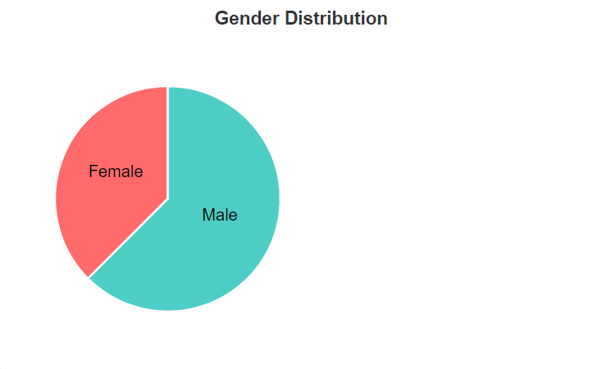

1. Histogram

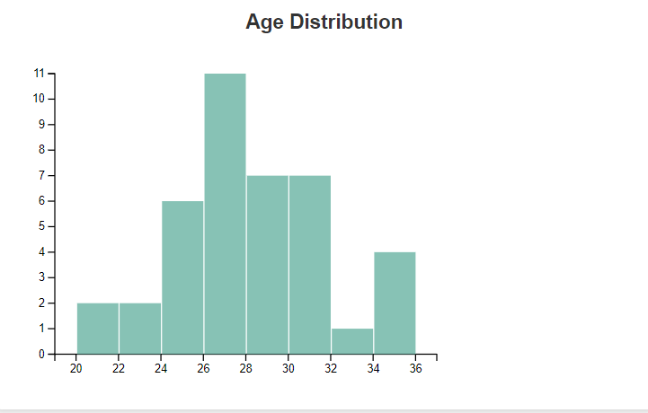

1. Bar charts

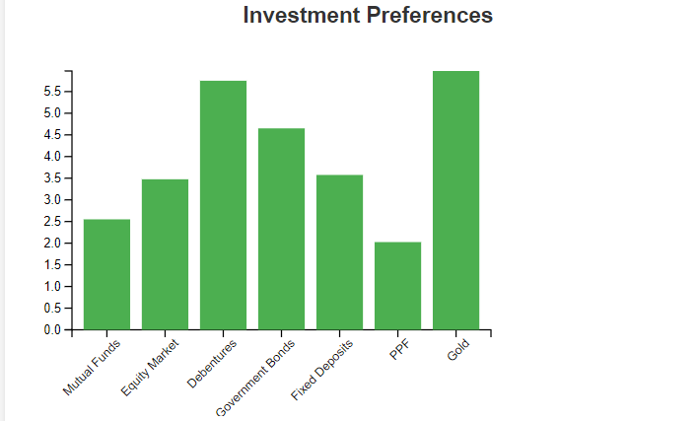

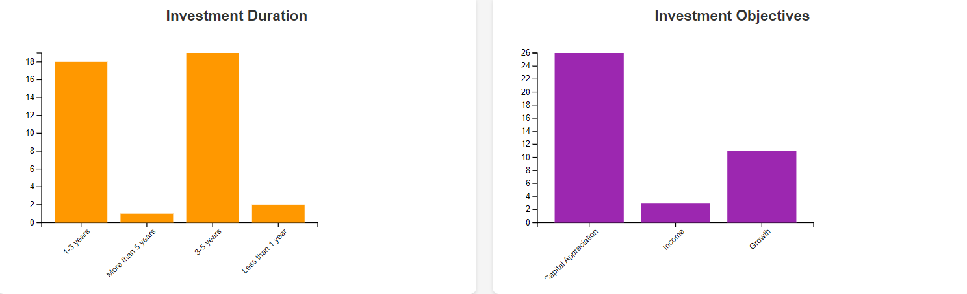

1. Donut Chart

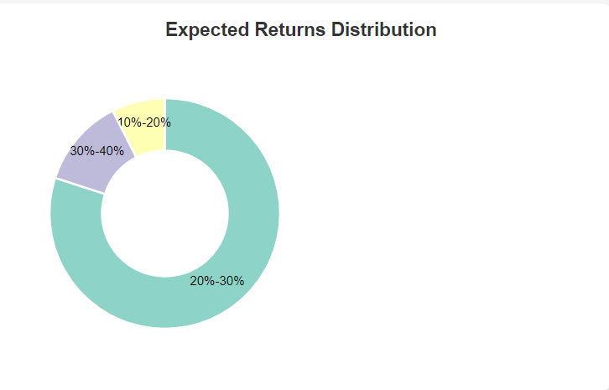

1. Advanced Plots

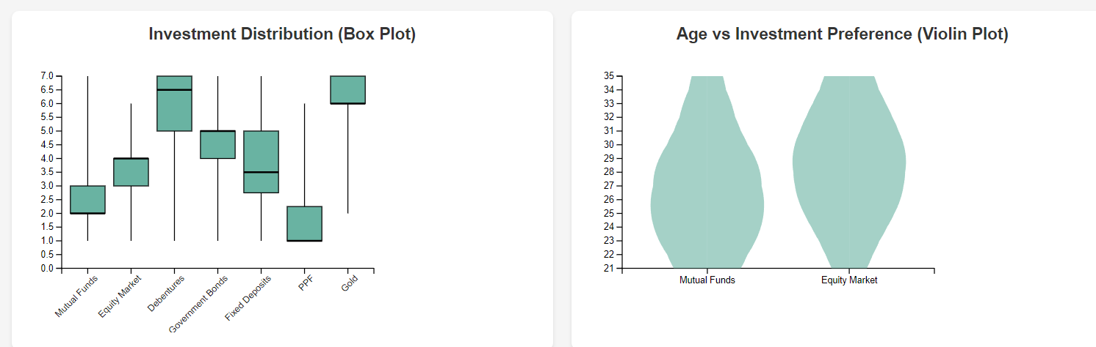

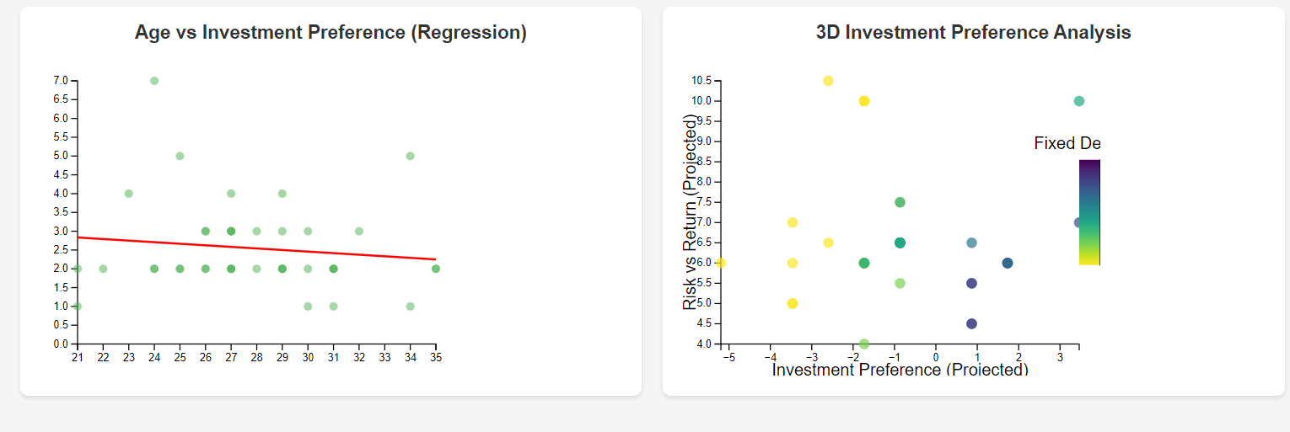

1. Hypothesis Testing

**Null Hypothesis (H0):** There is no significant difference in the mean expected returns between male and female investors.

**Alternative Hypothesis (H1):** There is a significant difference in the mean expected returns between male and female investors.

**Code:**

# %%

import pandas as pd

from statsmodels.stats.proportion import proportions_ztest

import numpy as np

from scipy.stats import norm

# %%

data = pd.read_csv('Finance_data.csv')

# %%

data.head()

# %%

# expect mapping

expect_mapping = {

    '10%-20%': 0.15,

    '20%-30%': 0.25,

    '30%-40%': 0.35,

    '40%-50%': 0.45,

    '50%-60%': 0.55,

    '60%-70%': 0.65,

    '70%-80%': 0.75,

    '80%-90%': 0.85,

    '90%-100%': 0.95

}

# %%

data['Expect_Numeric'] = data['Expect'].map(expect_mapping)

female_expect = data[data['gender'] == 'Female']['Expect_Numeric']

male_expect = data[data['gender'] == 'Male']['Expect_Numeric']

# %%

female_mean = female_expect.mean()

male_mean = male_expect.mean()

female_std = female_expect.std()

male_std = male_expect.std()

n_female = len(female_expect)

n_male = len(male_expect)

z_score = (female_mean - male_mean) / np.sqrt((female_std**2 / n_female) + (male_std**2 / n_male))

p_value = 2 * (1 - norm.cdf(abs(z_score)))

# %%

print(f'z_score: {z_score}')

print(f'p_value: {p_value}')

Output:

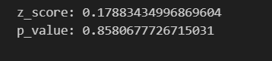

The P-Value here is is very high as compared to 0.05 so we fail to reject the Null Hypothesis(H0)

## Conclusion

* + This experiment enables an understanding of both basic and advanced data visualizations using **D3.js**, giving insights into the finance domain through visual exploration.
  + By performing hypothesis testing, you can statistically confirm relationships between variables, which is critical for data-driven decision-making in Finance/Banking/Insurance/Credit sectors.